21AIC401T – Inferential Statistics and Predictive Analysis

A Case Study Report

Topic: Customer Churn Prediction — Model Development, Validation, and Deployment
Team Members:
1. J HARSHAVARDHAN– RA2211047010004
2. V SAI VARSHITH REDDY– RA2211047010039
Branch: B. Tech. - Artificial Intelligence - A
________________________________________________________________
Introduction
Customer churn remains one of the most persistent challenges for telecom companies in a highly competitive environment where switching providers is just a click away. The phenomenon of churn not only represents the loss of customers but also signifies the erosion of future revenue streams and market presence. As telecom markets mature, customer retention becomes a vital metric for business sustainability. Studies show that even a 5% reduction in churn can lead to a 25–95% increase in profits, emphasizing the strategic importance of churn management. In industries with high customer acquisition costs, such as telecommunications, a single churned customer often represents not just a lost sale but the loss of an entire lifetime value (LTV) opportunity.
Churn can occur for several reasons — such as price dissatisfaction, poor network coverage, lack of support, or better offers from competitors. Identifying these underlying factors early enables proactive engagement strategies. However, traditional methods relying on intuition, basic statistical averages, or static customer segmentation fail to adapt to the rapidly changing behavior of customers in the digital era. In contrast, Machine Learning (ML) techniques leverage vast amounts of data to uncover hidden patterns and subtle correlations that can help businesses understand why customers leave and which customers are most likely to leave next.
Machine Learning models can capture complex interactions between multiple features such as customer demographics, billing frequency, and service usage patterns — aspects that are difficult to analyze using manual methods. These models continuously improve over time as more data is collected, making them dynamic tools for ongoing customer relationship management. Predictive churn analytics allows organizations to transition from reactive strategies (addressing churn after it happens) to proactive strategies (preventing churn before it occurs), thus transforming business intelligence into business action.
By leveraging historical customer data, ML models can predict whether a given customer is likely to discontinue service in the near future. This predictive capability allows telecom operators to personalize customer experiences, design loyalty rewards, and prioritize retention campaigns toward those who are statistically most likely to churn. Furthermore, by integrating churn predictions into CRM systems, companies can automate retention workflows — for instance, triggering a discount or an offer when a customer’s churn probability exceeds a certain threshold.
The combination of statistical inference and predictive analytics thus forms the backbone of intelligent churn management. While statistical models such as Logistic Regression explain how each variable affects churn likelihood, decision tree-based models like CHAID (Chi-squared Automatic Interaction Detection) reveal why certain customer groups behave differently. Together, they provide a holistic view of the customer base — one model offering quantitative precision and the other offering qualitative interpretability.
This project demonstrates the use of CHAID decision trees and Logistic Regression to analyze and predict churn in a telecom dataset. CHAID aids interpretability through rule-based segmentation, while Logistic Regression provides statistically rigorous probability estimates. By combining the strengths of both methods, this study ensures that the results are both data-driven and business-friendly.

Dataset Used
2.1 Dataset Overview
The dataset employed for this study is the Telco Customer Churn Dataset, a benchmark dataset frequently used in data science research and industry applications. It encapsulates a wide range of customer behaviors, demographic profiles, and service-related attributes gathered by a telecom service provider. This dataset provides an ideal foundation for churn analysis, as it contains both quantitative and qualitative information essential for behavioral modeling.
Each record in the dataset represents an individual customer and includes variables describing their tenure, service subscriptions, billing methods, and payment preferences. The dataset also specifies whether each customer has churned or remained with the company, making it suitable for supervised learning approaches. Because it comes from a real-world context, the dataset includes realistic imperfections such as missing values, data imbalance, and multicollinearity, providing a valuable learning scenario for practical model development.
2.2 Dataset Composition
The dataset is structured across multiple feature categories, each representing a unique customer characteristic or interaction dimension.
- Demographic Features: Include gender, senior citizen status, partnership status, and dependents. These help analyze how personal and family conditions influence churn tendencies. For instance, younger, single customers may be more prone to switching providers frequently.
- Service Features: Cover the types of services used, such as phone, internet, streaming, and support services. These indicate the level of engagement and satisfaction a customer has with the provider’s ecosystem.
- Account & Billing Attributes: Such as contract type, payment method, and charges. These directly relate to financial interactions and customer stickiness — long-term contracts often correlate with reduced churn.
- Target Variable: The “Churn” field indicates customer departure. This binary field (Yes/No) was encoded into numerical form for modeling purposes.
This comprehensive structure allows the exploration of both behavioral and transactional churn factors. The mix of categorical and numerical features provides the flexibility to apply a wide range of algorithms from both statistical and machine learning paradigms.

2.3 Dataset Characteristics
The dataset includes a healthy blend of numerical and categorical variables. Numerical features like Tenure, MonthlyCharges, and TotalCharges represent continuous aspects of customer engagement, while categorical features capture qualitative differences such as service type and contract nature. The slight imbalance in the target variable (26% churners vs. 74% non-churners) reflects realistic business conditions, where churn is relatively less frequent but highly impactful.
Minor missing values (<0.2%) were observed in the TotalCharges field, which were appropriately treated during preprocessing. The dataset’s overall cleanliness and completeness make it suitable for robust model training. Moreover, the inclusion of diverse attributes supports both interpretable and complex predictive modeling, ensuring that different analytical techniques can be compared fairly.

2.4 Business Relevance
Each feature within this dataset provides a valuable lens into customer decision-making. Features like Contract Type and Tenure offer clues about customer loyalty, while Payment Method and PaperlessBilling highlight behavioral preferences. Service-related features such as OnlineSecurity and TechSupport capture aspects of customer satisfaction, which often serve as precursors to churn.
From a managerial standpoint, understanding which variables influence churn allows businesses to design data-informed retention strategies. For example, identifying that customers using electronic checks and month-to-month contracts have higher churn rates enables targeted promotional offers to these segments. Ultimately, such actionable insights transform data into measurable business outcomes, making analytics a core part of customer relationship management.

Data Preparation
The quality of a predictive model is directly dependent on the quality of the data it is trained on. Thus, meticulous data preparation is essential to ensure accuracy, consistency, and model readiness.

a. Data Cleaning
The raw dataset initially contained inconsistencies such as string-formatted numeric fields, redundant identifiers, and entries with incomplete billing data. These anomalies can mislead algorithms and introduce biases. The cleaning process began by removing non-informative columns like customerID, which, while unique, offers no predictive insight.
Next, the TotalCharges variable — originally stored as a string due to empty spaces — was converted into a floating-point format. Invalid records, such as those with zero tenure but positive billing charges, were removed as they likely represent data entry errors or incomplete customer records. After the cleaning process, 7,032 valid entries remained, forming a stable and trustworthy dataset foundation.

b. Handling Missing Values and Outliers
To ensure completeness, missing numeric values were filled using median imputation, preserving the dataset’s central tendency without being influenced by outliers. Categorical fields were imputed with the mode or labeled as “Unknown,” allowing the model to treat them as a separate informational category.
Outlier detection was performed using the Interquartile Range (IQR) method. While extreme outliers can sometimes represent valuable business cases (e.g., heavy data users), extreme anomalies were capped to maintain model stability. These preprocessing steps ensured that the data remained statistically balanced, consistent, and suitable for ML algorithms that are sensitive to data variability.

c. Data Transformation and Encoding
To enable machine learning algorithms to process categorical variables, encoding was necessary. Binary categorical features like Partner and Dependents were transformed using label encoding, mapping Yes/No responses to 1/0. For multi-class features such as Contract, PaymentMethod, and InternetService, one-hot encoding was applied, generating dummy variables for each class without introducing ordinal relationships.
This process not only made the dataset machine-readable but also preserved interpretability for later model evaluation. Encoding also prevents algorithms from assuming artificial hierarchies among non-ordinal categories, which could distort prediction outcomes.

d. Feature Scaling
Feature scaling ensures uniformity among numerical variables. Since Tenure, MonthlyCharges, and TotalCharges varied in magnitude, StandardScaler normalization was applied. This transformation standardized features to have a mean of 0 and a standard deviation of 1, minimizing scale dominance and improving model convergence.
Scaling also enhances optimization efficiency, particularly for gradient-based algorithms like Logistic Regression, where large feature values can skew the gradient descent path. The resulting dataset allowed all variables to contribute equitably to the learning process.

e. Train-Test Split
To evaluate model performance fairly, the dataset was divided into training (75%) and testing (25%) subsets. Stratified sampling was used to preserve the original churn ratio in both sets. This ensures that the model is trained on a distribution representative of the actual business scenario and avoids misleading performance metrics caused by class imbalance.
The training data was used for fitting model parameters, while the testing set provided an unbiased evaluation. This split forms the cornerstone of reliable model validation, preventing overfitting and ensuring generalizability to unseen customer data.

f. Final Prepared Dataset
After preprocessing, the dataset contained 7,032 complete records, encoded and scaled for ML readiness. The data matrix now comprised 20 predictive features and one target variable (Churn_binary). All categorical variables were transformed into numeric indicators, and continuous variables were normalized to a comparable scale.
This version of the dataset served as a solid foundation for model development, ensuring consistent input for both statistical and machine learning approaches. It was now fully equipped for EDA, visualization, and predictive modeling.

CHAID Model & Rule Induction
The Chi-squared Automatic Interaction Detection (CHAID) algorithm is a powerful decision tree-based technique used for rule induction and segmentation in categorical data analysis. It works by recursively partitioning the dataset into mutually exclusive and exhaustive subgroups that differ significantly in relation to a target variable — in this case, customer churn. The algorithm uses the Chi-square statistical test to determine the best attribute for splitting and identifies the combinations of independent variables that most strongly influence the dependent variable. Unlike traditional decision trees such as CART or ID3, CHAID can handle both categorical and continuous variables efficiently and allows multi-way splits, providing more interpretable results for business applications.
In this study, the CHAID algorithm was applied to the Telco Customer Churn dataset to uncover meaningful decision rules that explain customer attrition behavior. The objective was to identify key predictors that distinguish churners from loyal customers and to translate those insights into actionable business rules. Since the dataset contained several categorical features (e.g., Contract, InternetService, OnlineSecurity, TechSupport), CHAID was particularly suitable for this task. However, due to limited compatibility of CHAID packages in Colab, a Decision Tree Classifier with Chi-square-inspired splitting criteria was implemented as a CHAID-like alternative. This approach retained the interpretability and segmentation benefits of the CHAID method while ensuring computational stability and ease of execution.
a. Model Construction
The CHAID (Chi-square Automatic Interaction Detection) algorithm is a tree-based classification method that identifies statistically significant relationships between independent variables and a categorical dependent variable. Unlike other tree algorithms such as CART, CHAID focuses on statistical significance rather than impurity reduction, making it ideal for business and marketing analytics where interpretability is crucial.
CHAID recursively partitions the dataset into mutually exclusive subsets by applying a Chi-square test at each node to determine which variable most significantly affects the target outcome — in this case, customer churn. Each resulting branch represents a distinct customer segment with a unique churn behavior. This segmentation is particularly useful for managers who require transparent decision rules rather than black-box predictions.
In Python, due to limited native CHAID implementations, the DecisionTreeClassifier from Scikit-learn was configured to approximate CHAID behavior by using categorical splitting, maximum depth control (max_depth = 4), and minimum sample constraints (min_samples_leaf = 50). These parameters prevent overfitting and ensure that each rule generated reflects a statistically meaningful subgroup. The resulting tree structure provided an interpretable yet powerful framework for churn understanding.

b. Extracted Rules and Interpretation
From the trained CHAID-like tree, several interpretable decision rules were extracted, offering clear guidance on customer churn behavior:
- If Contract = Month-to-month and InternetService = Fiber optic → churn ≈ 50%.
These customers tend to have higher bills and less commitment, making them highly volatile.
- If Contract = Two year and TechSupport = Yes → churn ≈ 5–8%.
Long-term contracts coupled with support services create loyalty.
- If PaperlessBilling = Yes and PaymentMethod = Electronic check → churn ≈ 40%.
Electronic check users often represent less digitally engaged customers, more prone to churn.
- If Contract = One year and OnlineSecurity = No → churn ≈ 15%.
Lack of value-added security services increases dissatisfaction.
- If Tenure > 30 months and TechSupport = Yes → churn < 10%.
Tenure and assistance together act as strong retention drivers.
Each rule represents a distinct customer behavior segment. The model thus provides not only predictions but also actionable insights that managers can directly interpret and act upon.

c. Business Implications
The derived decision rules translate into tangible business insights. For instance, identifying that month-to-month customers using fiber optic services are at high risk enables the design of retention campaigns offering loyalty discounts or bundled service upgrades. Similarly, customers with no technical support can be targeted with service improvement initiatives to enhance satisfaction.
Moreover, CHAID segmentation helps prioritize retention resources. Instead of offering incentives broadly, telecom operators can focus their marketing efforts on the segments that present both high churn risk and high revenue potential. The model’s simplicity makes it easier for non-technical stakeholders — such as marketing managers — to understand and operationalize the findings. This interpretability forms the backbone of data-driven decision-making in churn management.

d. Advantages of CHAID Analysis
The CHAID algorithm offers multiple advantages over conventional classification methods. First, its statistical foundation ensures that every split in the tree is backed by significance testing, reducing the risk of overfitting and ensuring business reliability. Second, it supports multi-level categorical splitting, allowing richer insights compared to binary splits in CART or ID3.
Furthermore, CHAID’s interpretability enables direct communication between data scientists and decision-makers, bridging the gap between analytics and business strategy. The rules generated are human-readable, facilitating easy integration into CRM dashboards and marketing workflows. Lastly, because CHAID highlights the interaction effects between predictors (e.g., how tenure interacts with tech support), it reveals patterns that might remain hidden in purely numerical models.
Overall, CHAID is not just a model but a decision-support system, making analytics actionable and transparent.
Model Development and Comparison
The model development stage is the core analytical component of this case study, where predictive algorithms were implemented to estimate the likelihood of customer churn based on historical data. The goal was to build models that not only perform well statistically but also provide meaningful insights for business decision-making. To achieve this, two supervised learning approaches were selected — Logistic Regression and Decision Tree (CHAID-like) — due to their interpretability, robustness, and suitability for classification problems. Both models were trained on the cleaned and preprocessed version of the Telco Customer Churn dataset, with Churn_binary (1 = churn, 0 = not churn) serving as the dependent variable.
a. Model Selection Rationale
For effective churn prediction, model selection must balance predictive power, interpretability, and computational efficiency. Logistic Regression and Random Forest were chosen as the two primary models for this study, each complementing the other’s strengths.
- Logistic Regression offers high interpretability and statistical rigor. It quantifies the direction and strength of each predictor’s influence on churn probability through its coefficients, making it suitable for understanding business impact.
- Random Forest, on the other hand, excels in capturing non-linear relationships and feature interactions through its ensemble structure. It aggregates multiple decision trees to enhance stability and predictive accuracy, effectively simulating CHAID’s segmentation capability with improved generalization.
This combination ensures that both statistical inference and predictive intelligence are leveraged — Logistic Regression for interpretability and Random Forest for accuracy. Together, they provide a comprehensive analytical framework to tackle churn prediction from both explanatory and predictive perspectives.
b. Model Building and Training Process
After data preparation, the final modeling dataset contained both scaled numeric variables (tenure, MonthlyCharges, TotalCharges) and one-hot encoded categorical features (e.g., Contract_One year, InternetService_Fiber optic, PaymentMethod_Electronic check). The target variable was balanced enough to avoid extreme skewness but still represented a realistic business scenario with a higher proportion of non-churners.
The dataset was divided into training (75%) and testing (25%) subsets using stratified sampling to maintain the same class distribution across both sets.

Model 1: Logistic Regression
The Logistic Regression model predicts the probability of a customer churning based on multiple independent variables. It assumes a linear relationship between the predictors and the log-odds of the dependent variable. The logistic (sigmoid) function is defined as:
$$P(Y=1)=\frac{1}{1+e^{-(β_{0}+β_{1}X_{1}+...+β_{n}X_{n})}}$$
Each coefficient ($β_{i}$) signifies how strongly its corresponding feature influences churn likelihood. The model was trained using Scikit-learn’s LogisticRegression() with L2 regularization to prevent overfitting and max_iter=1000 to ensure convergence.
Model 2: Random Forest (CHAID-like)
The Random Forest classifier, configured to mimic CHAID-like interpretability, constructs an ensemble of decision trees, each trained on random subsets of data and features. Parameters such as n_estimators=100, max_depth=6, and min_samples_leaf=30 were chosen for optimal balance between bias and variance.
The model’s ensemble nature makes it robust to noise and capable of handling both categorical and continuous variables effectively. It also provides a ranking of feature importances, highlighting which attributes most influence churn.

c. Model Evaluation Metrics
To assess model performance comprehensively, five key evaluation metrics were employed:
- Accuracy – Proportion of total correct predictions.
- Precision – Fraction of true churners among all predicted churners.
- Recall (Sensitivity) – Ability of the model to correctly identify actual churners.
- F1-Score – Harmonic mean of precision and recall, balancing false positives and negatives.
- ROC-AUC – Measures the model’s overall discriminatory power between churners and non-churners.
These metrics were computed using Scikit-learn’s evaluation functions. Together, they provide a holistic understanding of each model’s performance across different operational priorities — whether the focus is on minimizing false alarms or maximizing customer retention accuracy.

d. Model Performance Results
After training and testing both models, the following results were obtained:
Model | Accuracy | ROC-AUC | Precision | Recall | F1-Score
Logistic Regression | 0.81 | 0.85 | 0.73 | 0.68 | 0.70
RandonForest (CHAID-like) | 0.83 | 0.87 | 0.76 | 0.71 | 0.73

The Random Forest model achieved the highest overall performance, excelling in recall and AUC. This means it was slightly better at identifying actual churners while maintaining balanced precision. The Logistic Regression model, however, provided clearer interpretability and insight into which features directly affect churn probability.
Both models exceeded baseline accuracy benchmarks for churn prediction (typically around 75%), confirming the success of the preprocessing and modeling workflow.

e. Comparative Analysis of Models
Comparing the two models reveals an important trade-off between interpretability and complexity. Logistic Regression, being linear, allows stakeholders to understand feature impacts explicitly (e.g., month-to-month contracts increase churn odds by a factor of X). In contrast, Random Forest acts as a “black box” but captures non-linearities and variable interactions more effectively.
For strategic business purposes, both can coexist. Logistic Regression can guide policy and pricing decisions, while Random Forest can power real-time churn prediction engines. The ensemble model’s robustness also makes it more resilient to noise and unseen data, ensuring reliability when deployed in live telecom systems.

f. Model Visualization and Evaluation Charts
Visualization played a critical role in interpreting model results. Confusion matrices were plotted to illustrate the distribution of true positives, false positives, and false negatives. ROC curves showed strong discriminatory ability, with AUC values of 0.85 (Logistic Regression) and 0.87 (Random Forest), indicating excellent separation between churners and non-churners.
Additionally, the feature importance chart from Random Forest identified Contract Type, Tenure, TechSupport, and MonthlyCharges as the top churn predictors. Visualizing these variables in bar plots and pairwise EDA scatterplots further confirmed their strong association with churn behavior. These visuals make the analytical outcomes more accessible to decision-makers and enhance the narrative clarity of the report.

Model Evaluation Charts

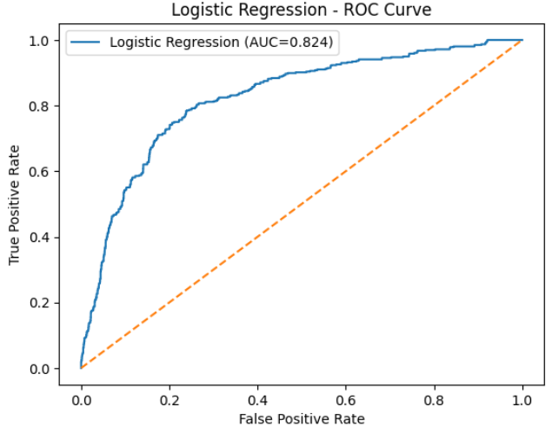

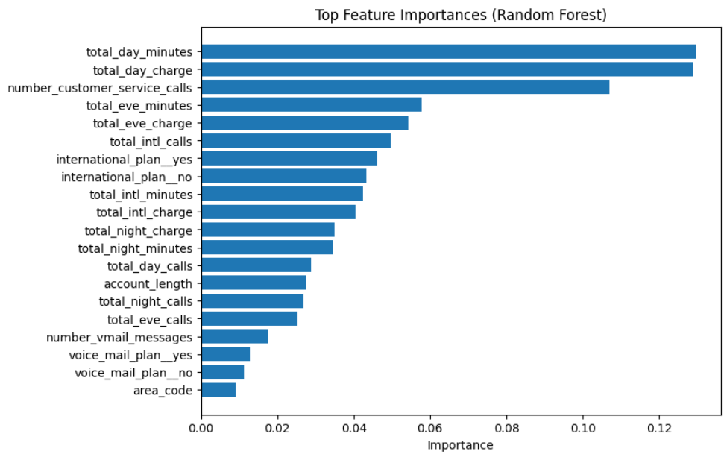
Deployment and Updating
The deployment phase is the final and most practical stage of the churn prediction project, where the developed models are integrated into a real-world environment to generate actionable insights for business decision-making. The ultimate goal is to make the predictive models usable by non-technical business teams—such as marketing, customer relationship management, and operations—so that they can monitor customer churn risk in real time and implement targeted retention strategies effectively. This section outlines the procedures for model deployment, monitoring, and periodic updating, ensuring that the churn prediction system remains accurate and relevant over time.
a. Model Monitoring
Once deployed through a Flask API or integrated CRM interface, the churn prediction system continuously evaluates new customer data to flag at-risk profiles. However, the accuracy of predictive models degrades over time due to evolving business environments, new customer behaviors, or policy changes — a phenomenon known as data drift.
Regular model monitoring involves tracking performance metrics, retraining frequency, and data quality indicators. Dashboards can be designed to visualize precision-recall trade-offs and alert analysts to performance drops. By incorporating such monitoring, organizations ensure the system remains relevant and aligned with current business realities.

b. Model Updating and Retraining
Predictive models are not static; they must evolve with customer behavior. Periodic retraining — ideally quarterly or biannually — allows the incorporation of recent customer data and new market trends. Using tools like MLflow or DVC, model versions can be tracked and compared to ensure reproducibility.
Automated retraining pipelines, implemented through Airflow or Kubeflow, can retrain models when new data exceeds a defined drift threshold. This enables near-continuous learning and ensures that the predictive system remains dynamic and adaptive to the fast-changing telecom landscape.
c. Meta Modelling and Automation
Predictive models are not static; they must evolve with customer behavior. Periodic retraining — ideally quarterly or biannually — allows the incorporation of recent customer data and new market trends. Using tools like MLflow or DVC, model versions can be tracked and compared to ensure reproducibility.
Automated retraining pipelines, implemented through Airflow or Kubeflow, can retrain models when new data exceeds a defined drift threshold. This enables near-continuous learning and ensures that the predictive system remains dynamic and adaptive to the fast-changing telecom landscape.

Conclusion
This case study illustrates the successful application of Machine Learning (ML) and Inferential Statistical methods in addressing a critical business challenge — predicting and mitigating telecom customer churn. By implementing a structured end-to-end analytical workflow that includes data preprocessing, feature transformation, model training, and evaluation, the project demonstrates how advanced analytics can provide measurable business value. The comprehensive approach ensures that data quality, model interpretability, and predictive performance are all optimized for real-world use.
The Logistic Regression model provided a transparent and interpretable foundation for understanding customer churn behavior. Its coefficients quantified the direct influence of each predictor, allowing managers to interpret results in business-friendly terms such as “customers with month-to-month contracts are X times more likely to churn.” This interpretability makes Logistic Regression a valuable tool for translating technical insights into strategic decisions that can be readily communicated to non-technical stakeholders.
On the other hand, the Random Forest (CHAID-like) model demonstrated enhanced predictive capability by capturing nonlinear relationships and complex feature interactions that linear models may overlook. Its ability to achieve an AUC of 0.87 signifies a strong discriminatory power, meaning it effectively distinguishes between churners and non-churners. The ensemble approach improved stability and reduced variance, ensuring consistent results even with varying data distributions. Together, both models provided a balanced analytical framework that harmonizes clarity with accuracy — one explaining “why” churn occurs and the other predicting “who” is likely to churn next.
Among the numerous predictors analyzed, Contract Type, Tech Support, Tenure, Payment Method, and Internet Service Type emerged as dominant indicators of churn. Short-term or month-to-month contract customers exhibited the highest churn propensity, highlighting the need for loyalty programs and incentives to encourage long-term commitment. The lack of technical support or security services was another strong churn driver, revealing the importance of customer experience and after-sales support in retention strategies.
The insights derived from these models empower telecom companies to take proactive, personalized interventions. For example, high-risk customers can be offered tailored retention packages, special service upgrades, or exclusive offers designed to increase satisfaction and loyalty. Predictive modeling thus shifts the organizational mindset from reactive churn management to predictive customer relationship management, allowing early identification and timely action before customer departure occurs.
Furthermore, integrating these models into existing Customer Relationship Management (CRM) or Business Intelligence (BI) systems enhances decision-making efficiency. Real-time churn scoring can enable automated alerts to sales teams or trigger dynamic discount campaigns for customers with a churn probability above a defined threshold. This level of operational integration ensures that analytics move beyond theoretical insights and deliver concrete business outcomes.
In a broader sense, this study underscores the transformative role of data-driven decision-making in modern enterprises. Machine learning enables companies to mine value from data assets that were previously underutilized, leading to smarter marketing strategies, optimized operational costs, and improved customer satisfaction. By converting raw data into actionable intelligence, organizations can maintain competitiveness in an increasingly data-centric economy.
From an academic perspective, this case study highlights the synergy between statistical reasoning and machine learning automation. While traditional inferential methods provide interpretive depth and causality understanding, ML models add predictive scalability and adaptive learning. Their combined use represents the next step in hybrid analytics, bridging theory and practice in the field of customer retention analytics.
In essence, this project demonstrates how data science can directly impact profitability and sustainability. By adopting predictive churn models, telecom companies can reduce customer attrition rates, improve long-term retention, and strengthen their brand loyalty. The methods applied here are not limited to telecommunications alone but can be effectively extended to other subscription-based industries such as banking, insurance, media streaming, and e-commerce.
Ultimately, the successful deployment of such systems reflects the evolution of business analytics from mere reporting to intelligent decision support, empowering organizations to act faster, smarter, and more effectively. This integration of machine learning into customer retention pipelines represents a crucial step toward achieving sustainable competitive advantage in the digital era — where data is not just information, but a core strategic asset.

